

**Cohort 8 Group Members and Roles**

1. Steve Muiga - Project Lead

2. Huldah Kaura - Technical Lead

ICT Track Mentor’s Name - Abdul Rehmtulla

# **innov8Pulse**

‘Fueling innovation beyond the event’

# **Problem Background**

Hackathons have increasingly become recognized for competency and skills development (Komssi, Pichlis, Raatikainen, Kindström, & Järvinen, 2015). They provide various benefits for participants, including solving industry-specific challenges, engaging in collaborative learning, and acquiring industry-relevant skills through practical experiences (Silva, Khakurel, Happonen, Hynninen, & Porras, 2017). Additionally, hackathons help participants develop other in-demand industry skills. Hackathons can thus be strategically utilized to cultivate industry-focused skills among higher education students, enhancing their employability.

These hackathons have been used as a foundation to foster collaboration and innovation within corporate settings (Ratsoga & Primus, 2023), generate innovative technological ideas to extend projects beyond the hackathon itself, and launch products that address customer needs. Additionally, they are valuable tools in enhancing IT students’ problem-solving abilities, creativity, and preparedness for real-world challenges through practical, team-based experiences. They are widely acknowledged as valuable for developing programming skills, highlighting the need for improved models to fully leverage their educational benefits (Oyetade, Zuva, & Harmse, 2022). Hackathons are increasingly recognized as a powerful tool for building regional and global partnerships. They bring together entrepreneurs, governments, and international organizations to collaboratively address development challenges, particularly in Sub-Saharan Africa. Through these collaborative efforts, hackathons are becoming a trusted approach for driving innovation and sustainable development. Ultimately, hackathons even encourage the creation of start-ups making them invaluable to potentially solving some of the most socioeconomic issues.

However, many of these projects developed during hackathons do not continue after the event. This leads to a waste of time and resources that go into preparing and running these hackathons, as well as a lack of a longer impact. A study aimed to explore whether hackathon projects continue after the event and what factors influence their continuation, using data from the Devpost hackathon database, found that while over a third of projects show some continuation, the rate sharply drops after a few days, with only 5% continuing beyond five months (Nolte, Chounta, & Herbsleb, 2020). The study also noted that pre-event preparation, the number of technologies used, and winning a prize positively influence short-term continuation. Long-term continuation on the other hand is supported by skill diversity, skill matching, and the team’s intent to expand the project’s reach. These low rates of project continuation were consistent across hackathons regardless of whether they were designed for individual learning, fostering community, or promoting entrepreneurship, indicating that the outcomes of the hackathon are generally not sustained beyond the event itself.

From November 2021 to February 2022, semi-structured interviews were conducted with 20 hackathon participants from a company operating in six African countries, including Kenya. The study targeted participants from hackathons held between 2018 and 2020, exploring both project continuation and discontinuation. The key findings stated that out of the 20 projects, 65% were abandoned, 20% were still in progress and 15% had been implemented (Ratsoga & Primus, 2023). This showed a very high rate of project abandonment post-hackathon. While hackathons foster innovation and creativity, sustaining them after the event is challenging. Most of the hackathon projects produce prototypes and ideas, with very few producing fully done projects. While many participants express interest in project continuation, only a small percentage achieve implementation, suggesting that additional post-hackathon support and alignment with broader goals are necessary to improve project continuation.

Following these studies, we conducted two pilot studies to validate the continuity of hackathon projects after the event in which they are hosted, especially among tech students in Kenya. First, we asked 30 current tech students across 13 universities to determine if they had participated in a tech-related hackathon in the past two years, with 90% having participated, and 63% of these students intended to continue with the project post-hackathon. However, there was a disconnect between intention and actual outcome. We followed up to determine how many students continued their projects one week, one month, and six months after the hackathon. We found out that, 25% of them continued with the project for less than a week, 31% between a week to a month, another 31% for up to six months, and only 13% have their projects still ongoing. Despite their initial intentions, a significant number of students did not maintain their projects due to challenges such as lack of a clear plan for continuation, limited mentorship and guidance, and difficulty in team coordination.

The second pilot study followed an evaluation model used elsewhere (Wilson, 2021) that measured post-hackathon continuation one week after the event, one month after the event, six months after the event, and one year after the event in terms of GitHub contribution to the project, and pitching for fundraising and support for the project. Thus, we examined the GitHub repository of a project built during a hackathon organized by the National Research Fund (NRF), held between the 6th and 7th of June 2024, and noted that the last commits to the project were made on the 15th of July 2024, about a month after the hackathon, with no further contributions afterward. The results depict that the project was only active for the period of the hackathon, with barely any engagement after, ultimately leading to its abandonment. These findings from our second study align with what the 30 students indicated that initial intentions to continue the projects often falter due to various challenges, including lack of sustained motivation, insufficient mentorship, and limited access to resources.

# **Market Opportunity**

We examined two solutions in the market currently addressing the same problem, where we got Devpost and Eventornado. Devpost is a platform that allows software developers to host hackathons and participate in hackathon competitions. It lists hackathon competitions that have happened, those in progress, and those asking for signups (Devpost, 2024). It shows hackathon winners and prizes for the same. The other solution, Eventornado, is a hackathon platform that helps run hackathon competitions. It allows for event registration, team organization, and timeline management. It has features that enable participants of various hackathons to collaborate. It also provides judges who help to choose winners (Eventornado, 2024).

While these two solutions provide platforms for hosting hackathons and organizing these events, they do not offer a solution for follow-up post-hackathons. Most of the arrangements made are before the events and only during the events, with minimal to no interactions post-event. Our solution aims to leverage these gaps by providing post-hackathon engagement between hackathon participants and mentors. This will help provide guidance to the participants who wish to continue with their projects after the hackathon event. As a result, this will also reduce the amount of hackathon projects being abandoned post-event.

**How large is the market that you are targeting in terms of revenue, affected target audience, and contribution to the economy?**

# 

# **Solution Idea**

The target users of this solution are university students in Kenya who take part in tech-related hackathons. To identify the target users, we conducted a pilot study across 14 Kenyan universities on students pursuing tech-related courses. 90% of the survey participants had taken part in a tech-related hackathon in the last two years, with 65% of them having the intention of continuing with the project post-hackathon. Most of these students are however unable to proceed with their projects, due to a lack of continuation plan and access to industry mentors post-hackathon.

While there are hackathon participants in the corporate industry as well as participants who are not students, we aimed to focus on university students currently enrolled in tech-related courses. This is because of the ease of access to data from students and also based on our experience as student hackathon participants and planners, we understand the users’ needs better. We are also excited to build this solution for this specific target user because we understand the zeal of the students in their aim to make their projects a success. In addition to that, most of the students lack access to mentors as compared to the corporate participants, who are already working with these experts in the field.

*Solution Prototype*

The solution is a web-based platform that connects hackathon participants with experienced industry mentors to facilitate continuous project development after hackathon events. The core offering includes the ability to create profiles, submit projects, and match with mentors based on skills and project requirements. Participants can browse projects and collaborate with mentors through a built-in chat system.

*Technology choice*

Front end development:

1. HTML5 - it ensures the web application is structured in a semantic and accessible way. Its elements help in organizing content such as forms for profile creation, improving search engine optimization (SEO), and ensuring compatibility with different devices.
2. CSS allows for styling the app, ensuring an appealing user-friendly design. It helps make the web application responsive, ensuring a good experience across various devices.
3. JavaScript which enables dynamic interactions within the app. This is through Document Object Model (DOM) manipulation in real-time, enabling users to interact with the app smoothly.
4. React which was used for building user interfaces, particularly single-page applications. It enhances user experience by enabling fast updates without reloading the entire page, crucial for interactive elements like project submissions and mentor matches. React's component-based architecture allows reusability and scalability, making it an excellent choice for growing applications.

Backend development

Firebase was used for the backend development since it offers features like real-time database, authentication, and cloud storage. With the real time synchronization, users can see project updates, mentor matches and chats without refreshing the page. It can also scale as the platform grows, handling more users and data as needed.

*Process Description*

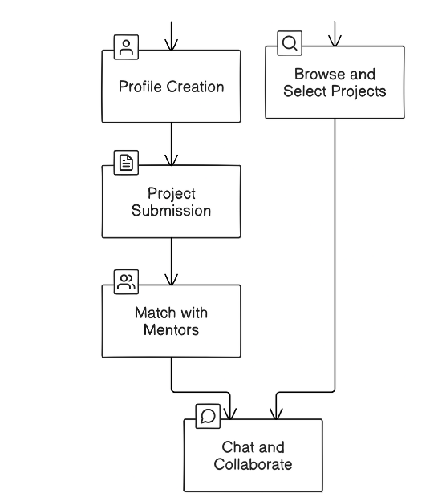

Profile creation: Users create an account by filling in username, email and passwords. Users can either sign in as mentors or hackathon participants. The participants are able to add their projects on the platform, while the mentors are can contribute to the projects and view them.

Project submission: Hackathon participants submit their projects for mentor evaluation. This step involves uploading project files or code, which is stored securely in the cloud.

Browse and select projects: Mentors can browse submitted projects, select ones to mentor based on their expertise, and provide feedback or support.

Chat and collaborate: Participants and mentors communicate in real time, exchanging insights or resources to enhance project development. Firebase’s real-time database facilitates these interactions.

*How the solution directly addresses the problem*

This solution directly addresses the challenge of project discontinuity after hackathons. By providing a structured way to match participants with industry mentors, it ensures that projects receive the guidance they need to develop into fully-fledged innovations. The chat and collaboration features also foster ongoing communication and support between mentors and participants, which is critical for project longevity.

*Assumptions Made*

1. The hackathon participants will be motivated to continue their projects post-event, seeking mentorship actively.
2. Industry mentors will be willing and available to offer ongoing guidance and support through the platform.

# **Value proposition**

Our platform empowers hackathon participants by seamlessly connecting them with industry mentors, ensuring continuous project development, personalized guidance, and real-world insights, ultimately enhancing their skills and fostering innovation. Through this, they can develop the project to a startup which will bring value to both the participants and the economy as a whole.

# **Designed Solution**

*Technologies Used*

Summarise here the technologies that you used, justifying the choices.

*Screenshots of Main Modules*

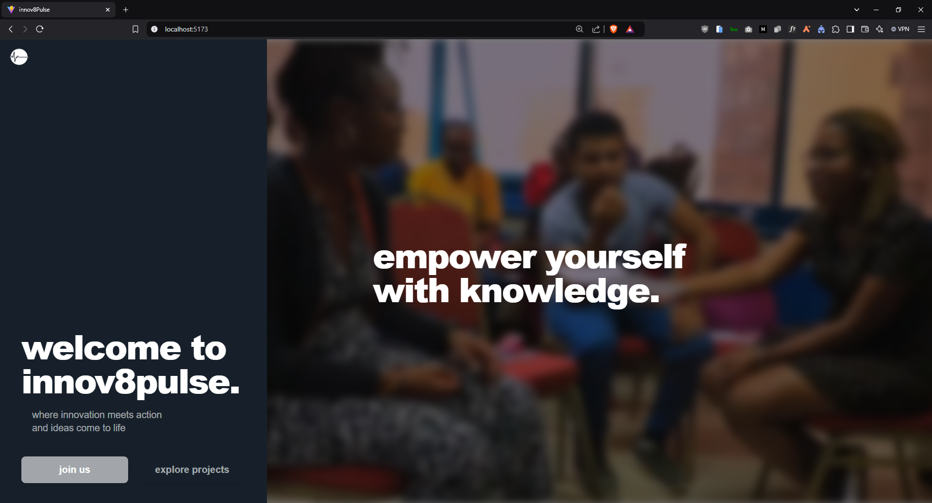

Landing page - This is the main home page when one opens the platform

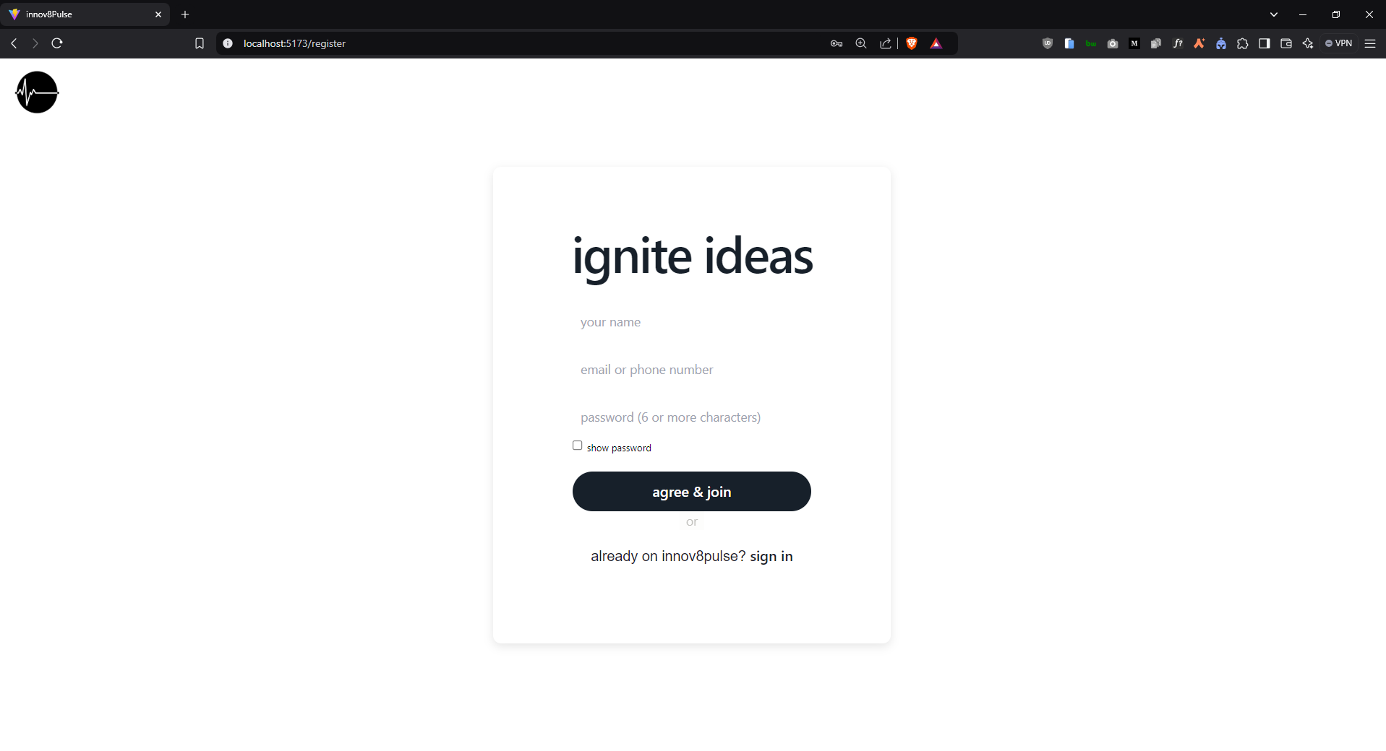

Sign up page

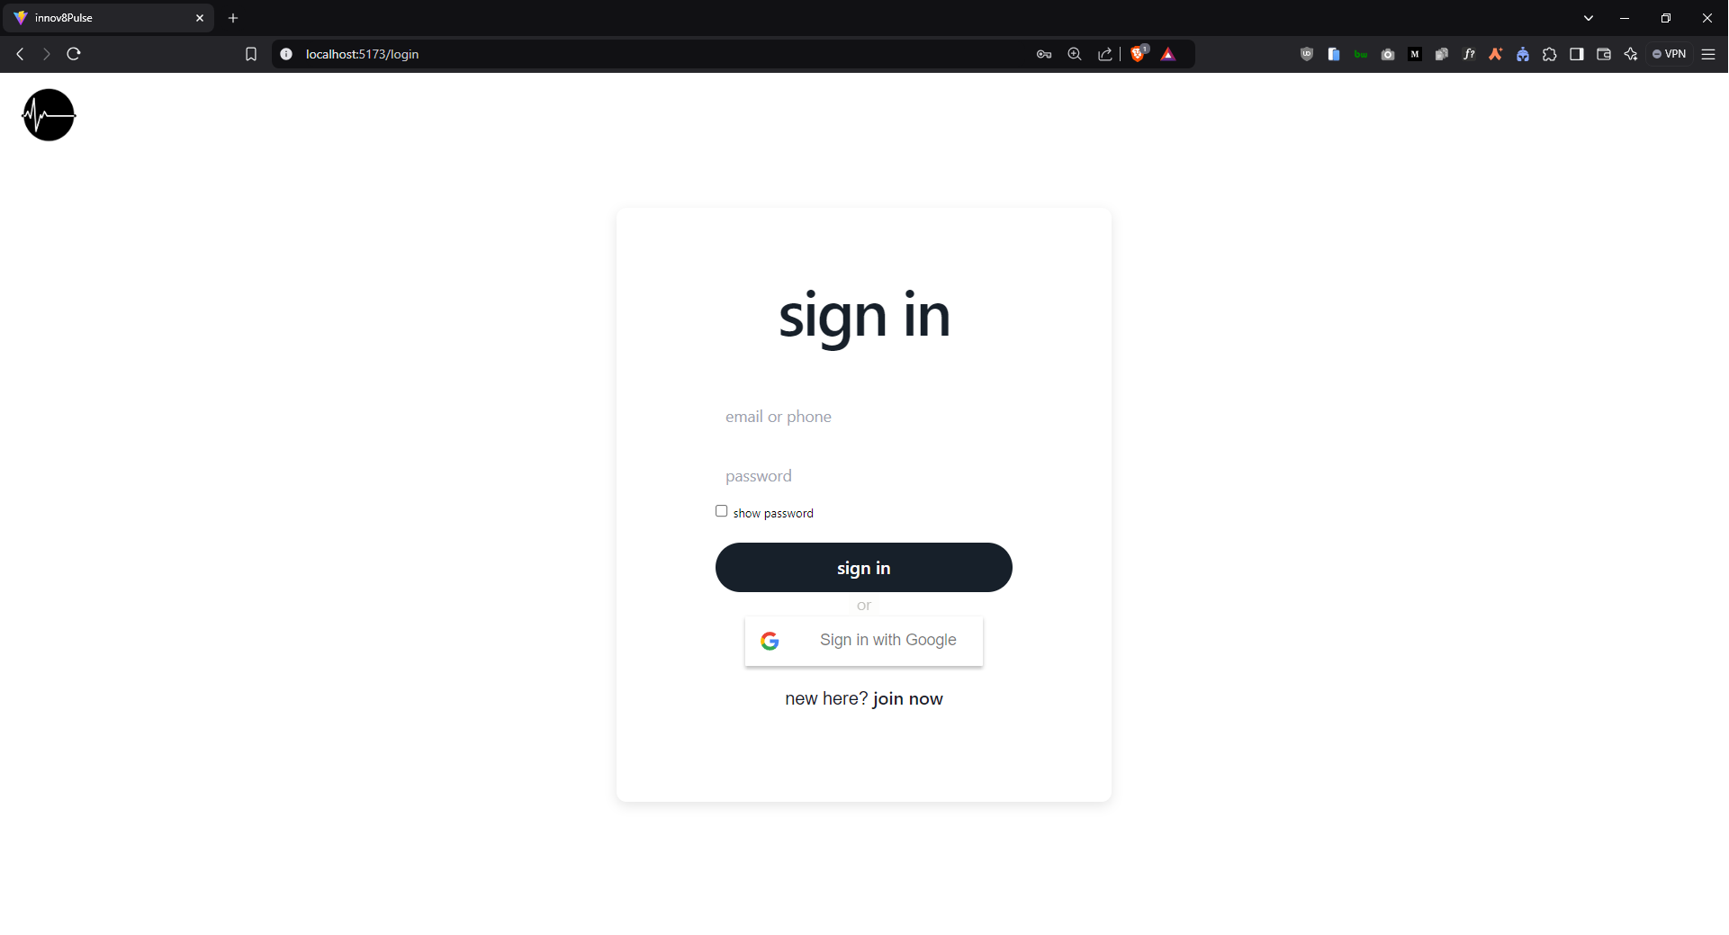

Sign in page

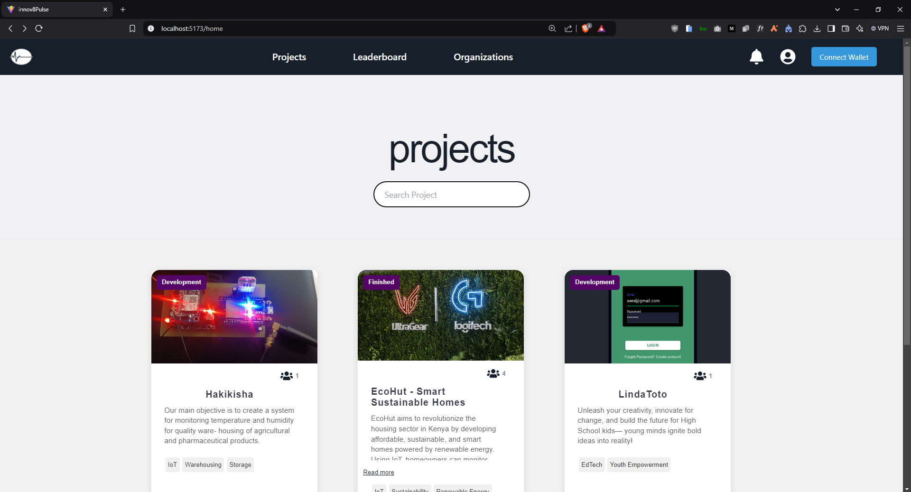

Project cards - After a hackathon participant submits their projects, they are listed here.

*Link to the solution*

GitHub link, and a link to the executable mode.

# 

# **Business Model**

Here, describe how you intend to make money (for-profit) or raise money (non-profit) and how you will ensure financial sustainability.

# **Responsible Computing**

The solution will include participants who have access to the internet

Here, describe how your solution is meant to meet [these](https://drive.google.com/file/d/1BdyqFl6PR8KpxWeJJ9tO9BMyR0Geyyb-/view?usp=drive_link) aspects of responsible computing.

# **Traction**

Milestones achieved so far:

1. We have done a pilot study among 14 universities who are the potential users of the product. Of the 31 participants, 90% of them had taken part in a tech related hackathon in the last two years. 65% of these had the intention to continue with their projects but had no plan for project continuation. This presents a clear need for this solution and product.

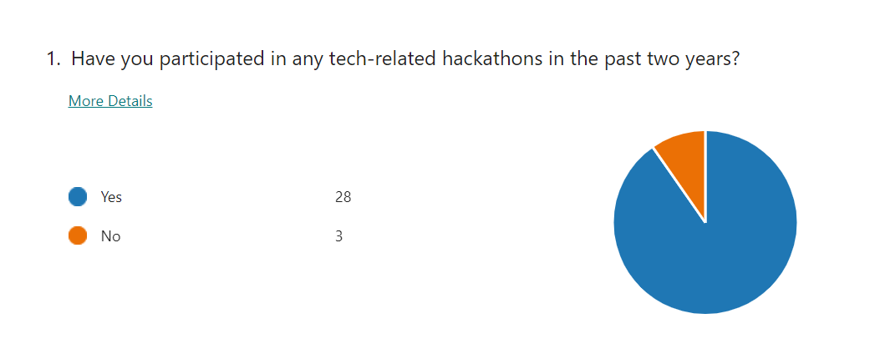

1. Branding -

During our brainstorming sessions, we decided to name our solution innov8pulse because we aim to create a solution that gives innovation a pulse even after the hackathon event. This is by ensuring project continuation post-hackathon. Our tag line, ‘Fueling innovations beyond the event’ clearly stipulates the aim of the solution. Below is a picture of our logo.



# **Funding/Support Need**

**Pilot Funding Plan:**

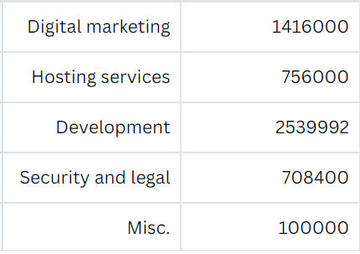

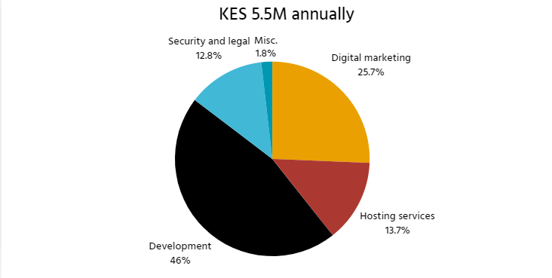

We will need 5,520,392 shillings annually for the pilot funding which translates to 16561176 for three years. This amount will go to the web application development, hosting services, security and legal, digital marketing and miscellaneous activity as illustrated above.

**Post Pilot Funding**

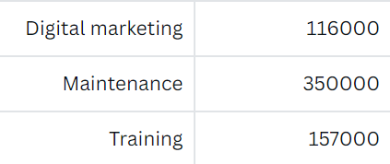

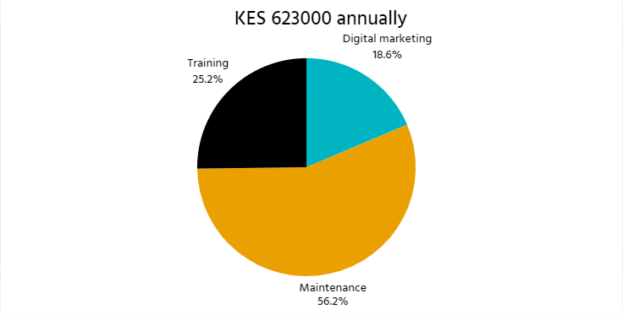

For the post pilot funding, we will need 623000 shillings, annually to cater for maintenance, digital marketing and training.

# 

# 

# 

# 

# 

# **Our team**



Steve Muiga, our team lead possess great leadership skills and is a highly technical web developer with skills in both frontend and backend development. He is responsible for both fontend development and part of the backend development. He has also been a part of writing the documentation of the project. He is highly skilled in writing creative and technical articles. He has also taken part in organizing hackathon events and understands the hackathon ecosystem.



Huldah is a backend developer and brings extensive knowledge of building digital platforms. She is responsible for both the development and research for the project as well as taking the lead in the documentation process of the project. In addition to that, she has taken part in hackathon competitions and understands the students’ perspective of hackathon participants.